Weekly Status Report 3

Week 3

Name: Joe Lanzi

# Activities and Accomplishments

* Finished the facial recognition capable of identification of persons with facial coverings with over 99% accuracy
* Finished a local Website in Html5, CSS3, and JavaScript
* Created a local Webserver in C capable of running html, css, and javascript which fully integrated all the software together in a local storage device
* Created a full software handler capable of automating all task to completion
* Created a network capable of wide world access

# Problems

* Facial Mask eliminates simple methods and causes expensive computations that must be solved with dedicated GPU’s locally or cloud-based computing

# Plans

* Improve software and wait for the hardware to be done

# Individual Hours Worked This Week on the Project

(Note: This is the total number of hours you actually worked on Capstone. Eg, if you have a team of 4 people, you worked together for 2 hours this week. **Individually, you worked 2 hours/4 =0.5 hour this week. You put 0.5 here.)**

|  |
| --- |
| 35.6 |

I worked on the project for **25 hours**

The group met for a total of **3 hours/5 people = 0.6**

# Discussion

The report below includes only my own work for the second week of Spring 2021.

Last week - I’ve informed the group to start working on the power of the whole system including calculations, integrate all hardware systems together, and start collecting testing data.

**This task has not yet been done.**

**Facial Detection & Recognition**

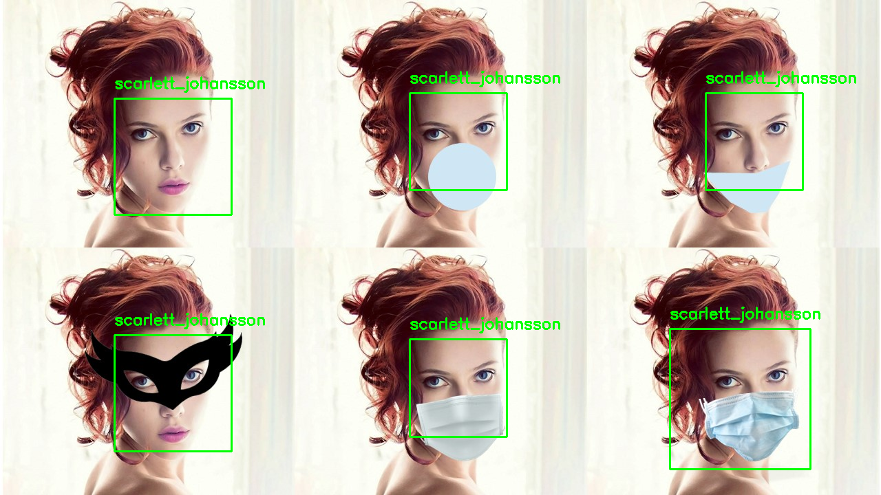

By understanding the facial landmarks of a person’s face. I was able to rewrite plenty of algorithms to train on a method closed to how humans identify individuals even with face coverings on. By training a model to create different weights and classification methods on small features of the body, the model can make associations to whom the person could be just like how people identify others. (More details in the final report)

In the picture above, a heavily modified region-based convolutional neural network (mRCNN) was capable of identifying the person in less than 2 seconds. The image includes 1 never seen original image for the base classification and 5 different facial coverings the model has never seen before. The 2 second classification time can only be achieved by using a deep learning method running on CUDA architecture on a GPU. If this pipeline was running on just a CPU machine, the classification time is 20x-30x slower. This concludes the facial recognition pipeline.

**Website using HTML, CSS, & JAVASCRIPT**

A new website was created because the old 3rd party websites post problems in data transfers, which either was impossible or cost monthly or yearly subscriptions. So, I explained to the group on the weekly meeting and task them with its completion.

**A week later and they still have not started**, so I decided to do it which took around 5-7hours.

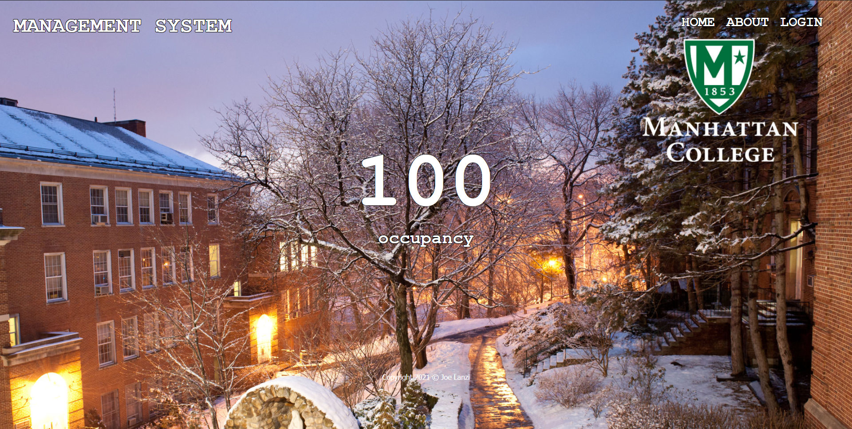

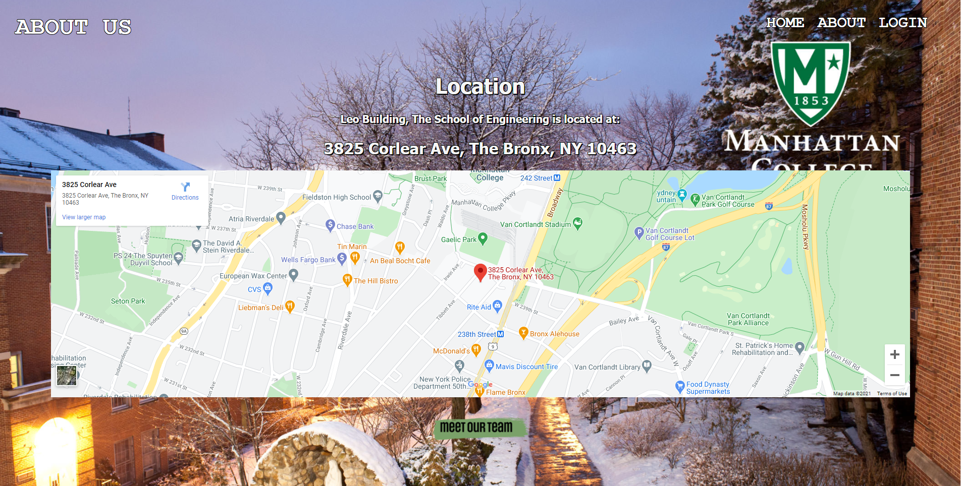

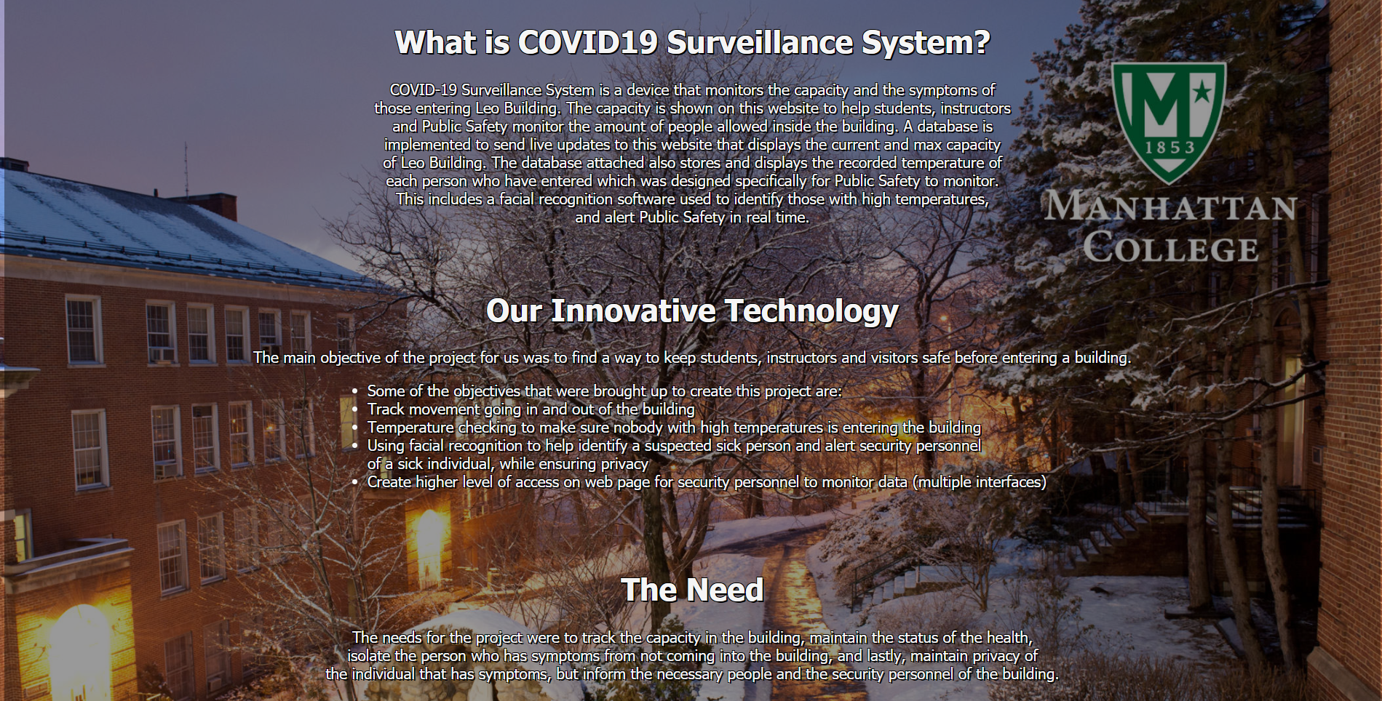

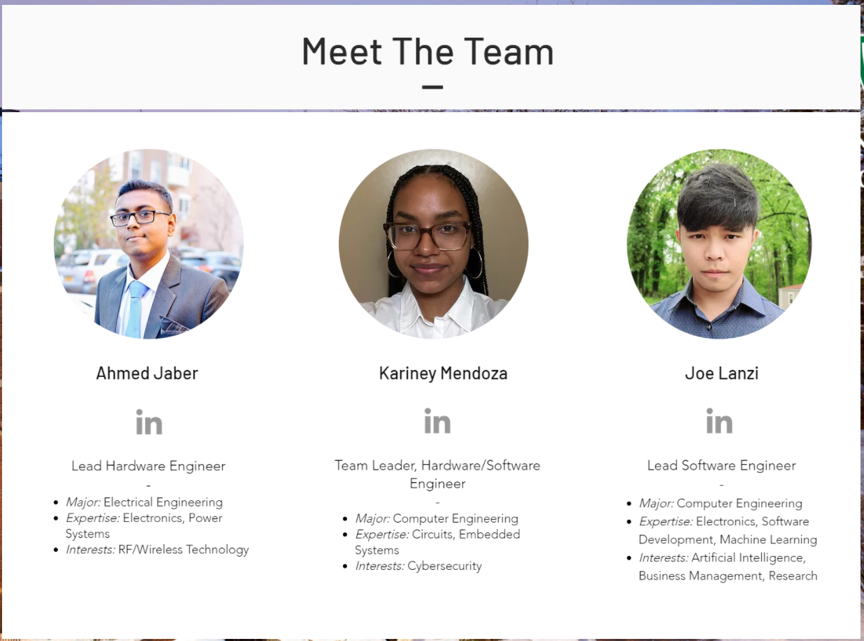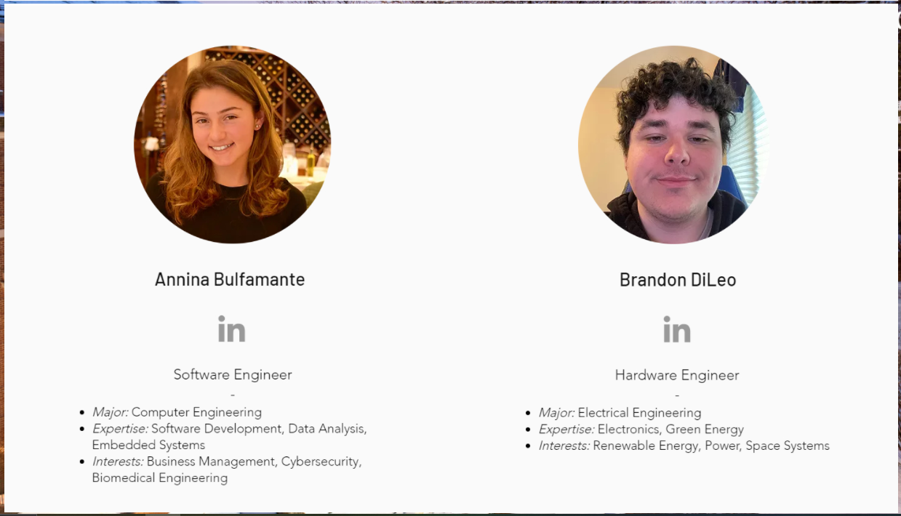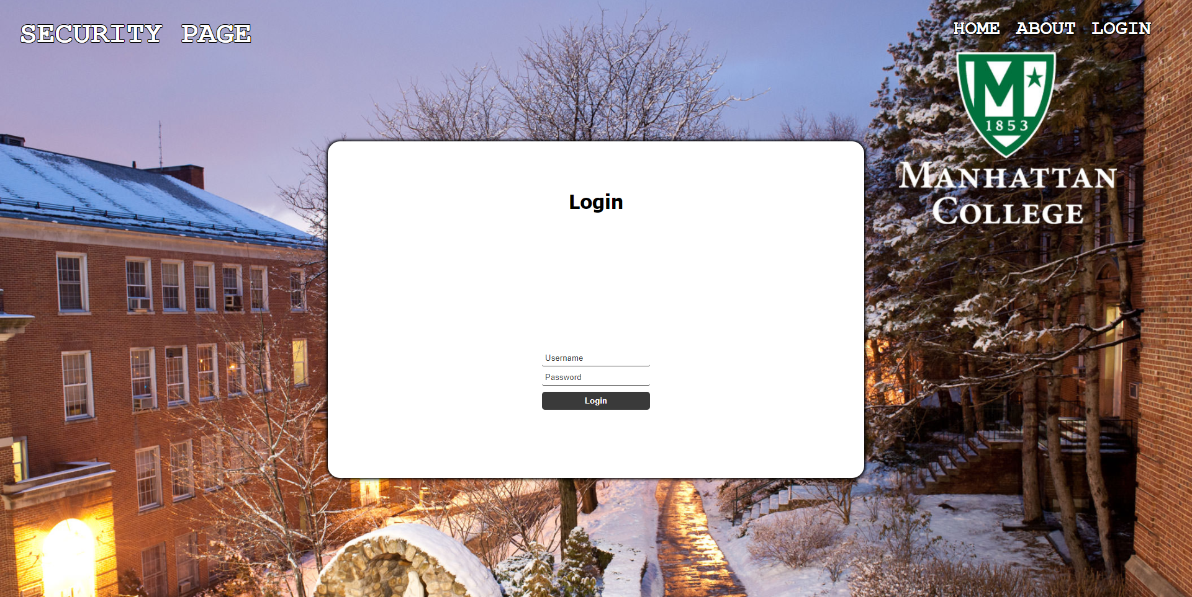

Above is the new simple but finished website equipped with JavaScript to complete simple functions such as logins and extracting data for the building occupancy. The next step is to complete the security page, which will be equipped with the facial recognition. So, from here on out, the website needs to integrate all data and integrate with the facial recognition technology.

**Webserver**

**Same thing here, the webserver was supposed to be done, but they still have not touched it. I literally gave them the code and showed them how to do it.**

The ESP32 contains a Serial Peripheral Interface Flash File System (SPIFFS). SPIFFS is a lightweight filesystem created for microcontrollers with a flash chip, which are connected by SPI bus, like the ESP32 flash memory. In this project I upload files to the ESP32 filesystem using a plugin for Arduino IDE.

SPIFFS lets you access the flash memory like you would do in a normal filesystem in your computer, but simpler and more limited. You can read, write, close, and delete files. At the time of writing this post, SPIFFS doesn’t support directories, so everything is saved on a flat structure.

Using SPIFFS with the ESP32 board is especially useful to:

* Create configuration files with settings.
* Save data permanently.
* Create files to save small amounts of data instead of using a microSD card.
* Save HTML and CSS files to build a web server. 🡨
* Save images, figures, and icons.

To make the webserver simpler, we can write it in HTML and CSS. Because with SPIFFS, you can write the HTML and CSS in a separated file and save them on the ESP32 filesystem to run without external resources.

After uploading the HTML, CSS, AND JAVASCRIPT files to the ESP32 using a filesystem uploader, our ESP32 can run the webserver with the embedded website on sole power and wifi.

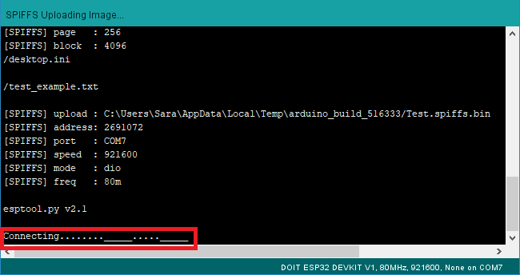

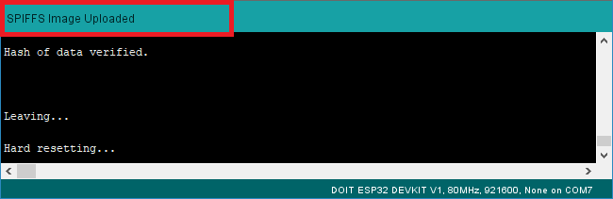

After wards, we upload the webserver code to our device to make the ESP32 a stand-alone webserver accessible by an IP address (because publishing and getting a public would cost money or will have to use a 3rd party once again causing problems to our data transfer).

